**Blue Ocean Strategy ERRC Analysis**

Report for Human Resources

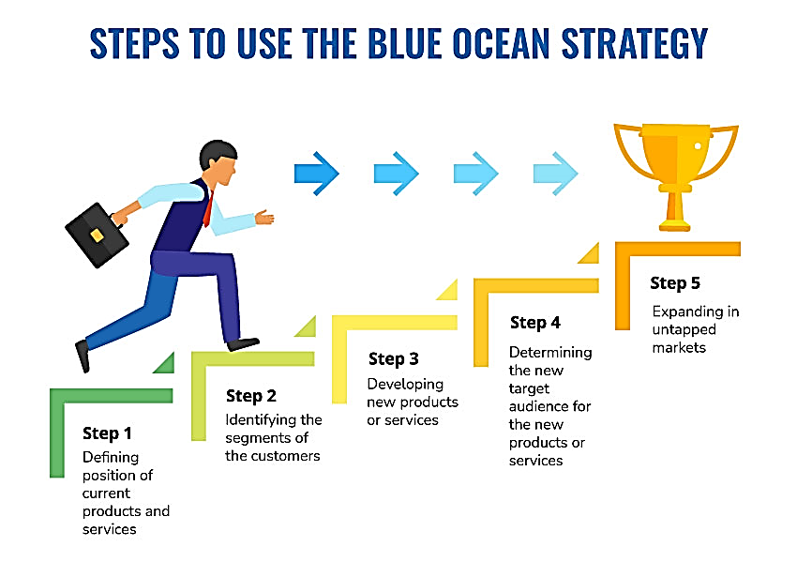

**Data Driven Decision Making**



**Data Dynamos**

For HR Data Analysis

**Blue Ocean Strategy) ERRC Analysis (Report for Human Resources**

**Introduction:**

Recent trends in the human resources sector indicate that traditional competition is no longer sufficient to guarantee excellence. The successful companies today are those that innovate in delivering unique value to both employees and employers. Through analyzing the current data, it appears there is a gap that can be filled by creating a new market (blue ocean) where competition is irrelevant.

**ERRC Analysis) Eliminate & Reduce & Raise & Create (**

**1. Eliminate:**

**A. Traditional Administrative Procedures:**

* **Problem:** The company manages data using traditional manual forms and procedures, leading to irregular and inaccurate recording of performance and training information. This method causes delays in data processing, reduces its efficiency in supporting decision-making, and makes it difficult to track employee development and improve their performance effectively.

**Reasons for the problem:**

* + More than case of incomplete performance data or missing values have been recorded.
  + Some training records are duplicated for the same employee without clarifying the training content.
  + There are no indicators linking evaluations, training, or promotions.
  + There is no digital tracking system or analytical dashboard to assess performance and training in real-time.
* **Opportunity:** Eliminate manual forms and convert the system into a smart digital platform that records performance and training in real-time.

**B. Fixed Promotion System:**

* **Problem:** Some employees experience career stagnation due to the reliance on seniority alone for promotions, without considering actual performance or acquired qualifications. Data shows that some employees have maintained high performance evaluations over long periods without receiving corresponding promotions. Additionally, some employees have stayed in the same job grade for over three years without changes in their roles or level.
* **Opportunity:** Eliminate the seniority-based promotion system and replace it with a system that relies on performance and acquired competencies.

**2. Reduce:**

**A. Reliance on External Training:**

* **Problem:** Some employees do not actively participate in training despite the available opportunities.
* **Opportunity:** Reduce reliance on external providers that do not meet internal training needs, and focus on developing in-house customized content, while ensuring better coordination between training and performance to guarantee integration within a comprehensive HR system.

**B. Frequent Business Travel:**

* **Problem:** Frequent business travel increases fatigue and reduces work-life balance.
* **Opportunity:** Reduce travel and convert meetings to virtual formats, which decreases costs and increases satisfaction.

**3. Raise:**

**A. Flexible Work Environment:**

* **Indicators:** Varied evaluations regarding work-life balance.
* **Opportunity:** Increase flexibility in the workplace, implement hybrid work policies, and provide additional paid mental health leave.

**B. Career Development Opportunities:**

* **Indicators:** Some employees feel there is no clear progression in their career path.
* **Opportunity:** Increase the number of training programs and provide customized career development plans for each employee.

**C. Technological Integration:**

* **Indicators:** There are no clear indicators of integration with performance analysis tools.
* **Opportunity:** Increase the use of business intelligence tools to identify outstanding employees early on.

**4. Create:**

**A. Digital Career Development Platform:**

* **Opportunity:** Create an internal platform that includes training programs, professional development challenges, monthly evaluations, and digital rewards, directly linked to the performance system.

**B. 360-Degree Evaluation Model:**

* **Opportunity:** Develop a new system where employees are evaluated by colleagues, internal clients, and managers, along with a self-evaluation to improve fairness and transparency.

**C. Mental and Physical Support Programs:**

* **Opportunity:** Establish initiatives such as "Mental Health Hour," group support sessions, and partnerships with healthcare applications.

**D. Internal Job Mobility:**

* **Opportunity:** Enable employees to move between departments to gain new experiences and expand their professional horizons within the company without the need to leave.

**Conclusion:**

By applying the Blue Ocean Strategy, the company can reshape its own market and create added value for both employees and clients alike. Focusing on innovation in the work environment, enhancing employee well-being, and empowering them for professional development represents a crucial step towards achieving sustainability and leadership in the human resources sector. This approach not only strengthens employee loyalty but also drives the organization towards higher performance and a stronger market position.



|  |
| --- |
| **Data Dynamos** |